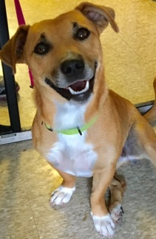
Olive, Mix,female, 30lbs, 1yr, extremely sweet & loving with a little bit of salty on top (she’s an olive after all! ), occasionally a tad stubborn but super easy to correct after a soft but high pitched invitation to do what you need her to do, great w/ people, great w/ dogs, cats, from a rural shelter, has a rear leg issue that we are having evaluating
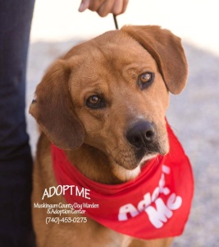
Mix, Brownie
55 lbs, super sweet, likes toys, balls, taking walks, cuddleing, plays, but LOVES petting and cuddling, good w/ dogs
Charlize, Pit Mix, 3yrs, 65lbs Charlize is a great dog! She is fully housebroken and she love to work. She went to her first agility competition and qualified in 7 of 8 events. She has a lot of energy when training, but is very calm and well-behaved in the house. She doesn't need to be crated and a baby gate leaning across the doorway is all that is needed to confine her.
Charlize has also learned a number of tricks and is basic obedience trained.
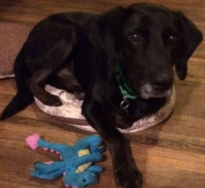
Lab/Hound Mix, Nester
60lbs, 4 yrs, the nicest, friendly pooch ever, this guy loves life, great w/ dogs, cats, rides well in car, needs to learn to walk on leash better as he pulls,
loves his toysMix, Robin
2 yrs, 31lbs,male, extremely happy, good w/dogs,calm,
loves walks! very cuddly and loves being around people,needs to put on weight,
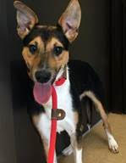
Mix, Pascal 20lbs, male, very shy, great w/ dogs, loves to play/run w/ his foster brother, still learning the sites/sounds of a regular home setting, came from a rural KY shelter, loves playing with toys, likes walks, but gets nervous so more walks will help his confidence, will do best in home with another dog
Rat Terrier Mix, Katie
female, 7yrs, 18lbs very good natured, very sweet, happy go lucky, rides well in the car, easily handled, has a lot of pep in her step, polite, great on leash
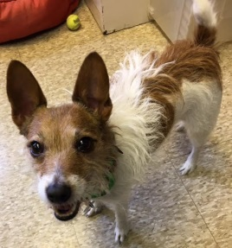Jack Russell, Jasmine
3 yrs, relatively laid back, a sweet little girl, best in home with older kids because of her strong personality and sometimes Jack Russell attitude, loves to go for walks and is content to spend evenings sitting on the sofa beside her person, Jasmine will do best as an only dog because she loves being the queen of her domain Chia Mix, Marin
female, 3yrs, 10lbs, came from a high volume breeder so learning what normal is, will need at least one other dog in the home to best adjust, Marin is awesome w/ dogs, she loves to play chase, , you can see the pure happiness in her bounce, she will take time to adjust, wants to interact w/ her humans but hesitant, she is a typical commercial breeder dog, very stiff when held, frightened of quick movements, loud noises, Marin will do best in an adult home with fenced yard. 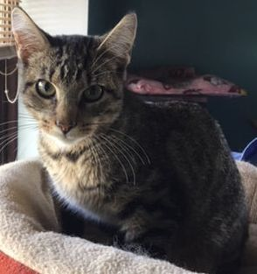
Fencie, male, sweet little boy, likes to play w/ look a like office kitty named Larry, loves to play on our jungle gym and explore like a typical kitty, sweet w/ all dogs and cats
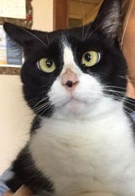Simon, our sweet little crossed eyed boy is such a nice kitty, his vision is impaired but he gets around well and even climbs in our cat jungle gym, declawed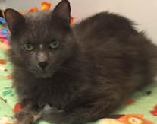Garfunkel is super nice as well, he lounges most of the time, both are low key declawed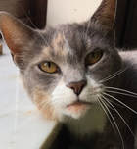Chloe, female, 4yrs
a pretty quiet girl that is a nice mix of independent but likes to have her time/attention with you,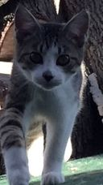Henry, THE most playful kitty on the planet, this little guy loves to explore, play w/ any of the cats in our office, chase dust balls across the room, a fun boy to have around, 5 months
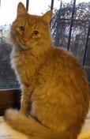Barry, male, 5 yrs superbly nice little guy, likes a gentle touch & does well w/ other kitties 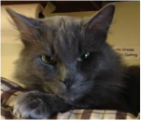
Smoke male, 4yrs, low key boy that was living on the street w/ his brother, seems a little more cautious than his brother but once he trusts you, he melts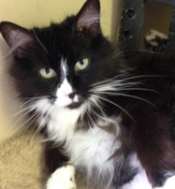Ripley, 5yrs
the nicest, calmest kitty ever, found fending for herself on the streets, gives the dogs the business to back off if they get too close, such a low key kitty, loves her belly rubbed, loves being near her person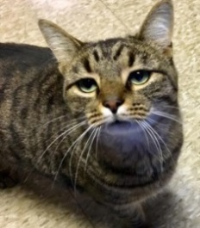Larry,​male, 5 yr low key kitty, very loving, easy going and does great w/ other cats
Mamma, female
9yrs, declawed, super affectionate kitty, loves to be near her people, a couch potato kind of kitty, easy & sweet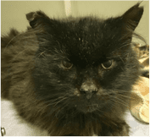
Harry, 10yrs, this old boy has been a street kitty for some time, as rough as it looks like life may have been to him, he is a very sweet kitty, most of his teeth had to be pulled, he's on a soft food that he will likely need life long, he is also FIV+, because he is so sweet, we assume he was someone's pet at one time, but he has lived in trailer park for many years and his ears are likely a sign of many cat fights, he is very low key and loves to curl up and sleep most of the time
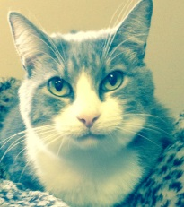
Stacey, 10yrs, declawed, this cat is fabulous, friendly, loves to be near her person, low key
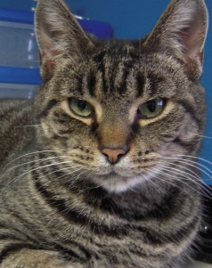
Fowler, male, short hair, 10yrs, low key cat, easy going with the other office cats, this boy is just a nice cat
Shirley, 7yrs, beautiful eyes, a quiet wall flower, but a perfect litter box user Shirley is just a nice cat, low key, loves attention but independent too, she is as solid grey as you have ever seen a cat be, she's an office favorite

