Mix, Mandie
1yr, 25lbs, this little sweetie is a very mellow little girl with an energy level you would normally associate with a much older dog, she is good with small dogs, she walks really well on a leash
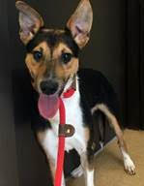
Mix, Pascal 20lbs, male, very shy, great w/ dogs, loves to play/run w/ his foster brother, still learning the sites/sounds of a regular home setting, came from a rural KY shelter, loves playing with toys, likes walks, but gets nervous so more walks will help his confidence, will do best in home with another dog
Chia Mix, Marin
female, 3yrs, 10lbs, came from a high volume breeder so learning what normal is, will need at least one other dog in the home to best adjust, Marin is awesome w/ dogs, she loves to play chase, you can see the pure happiness in her bounce, she will take time to adjust, wants to interact w/ her humans but hesitant, she is a typical commercial breeder dog, very stiff when held, frightened of quick movements, loud noises, Marin will do best in an adult home with fenced yard 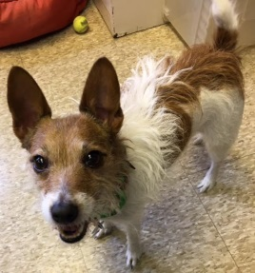Jack Russell, Jasmine
3 yrs, laid back, a sweet little girl, best in home with older kids because of her strong personality and sometimes Jack Russell attitude, loves to go for walks and is content to spend evenings sitting on the sofa beside her person, Jasmine will do best as an only dog because she loves being the queen of her domain 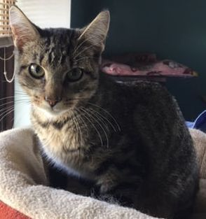
Fencie, male, sweet little boy, likes to play w/ look a like office kitty named Larry, loves to play on our jungle gym and explore like a typical kitty, sweet w/ all dogs and cats
Simon, our sweet little crossed eyed boy is such a nice kitty, his vision is impaired but he gets around well and even climbs in our cat jungle gym, declawed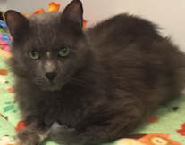Garfunkel is super nice as well, he lounges most of the time, both are low key declawed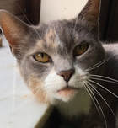Chloe, female, 4yrs
a pretty quiet girl that is a nice mix of independent but likes to have her time/attention with you,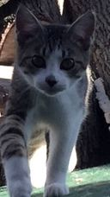Henry, THE most playful kitty on the planet, this little guy loves to explore, play w/ any of the cats in our office, chase dust balls across the room, a fun boy to have around, 5 months
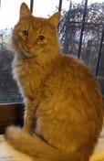Barry, male, 5 yrs, independent, likes to spend time in outside cat house
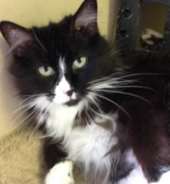Ripley, 5yrs
the nicest, calmest kitty ever, found fending for herself on the streets, gives the dogs the business to back off if they get too close, such a low key kitty, loves her belly rubbed, loves being near her person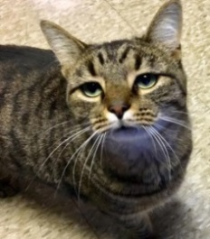Larry,​male, 5 yr low key, very loving, easy going and does great w/ other cats
Mamma, female, 9yrs, declawed, super affectionate kitty, loves to be near her people, a couch potato kind of kitty, easy & sweet
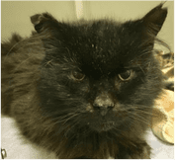
Harry, 10yrs, this old boy has been a street kitty for some time, as rough as it looks like life may have been to him, very sweet kitty, most of his teeth had a soft most of the time
Stacey, 10yrs, declawed, this cat is fabulous, friendly, loves to be near her person, low key
Mix, Meatloaf
5-6 yrs, has lived his entire life chained outside. He has never been in a house and has not known companionship. He is a big boy weighing 109 pounds but could stand to lose about 15. In spite of his isolation from his family, he is very friendly. Loves to sleep on a pile of comforters and is enjoying living inside. He is not good with cats, and introduction to other dogs would have to be slow. He would benefit from training and would do better in a home without younger children as he could knock them down. We are looking for a foster or better yet, permanent home.
He is receiving some basic obedience, loves to give sloppy kisses, and likes to ride shotgun
Chihuahua Mix,
Mrs. Flores
9 yrs, 10 lbs has had two surgeries and is now walking and playing. She even runs sometimes. She's a rolly polly that loves belly rubs and giving kisses. best in a adult home without rambunctious dogs, due to her orthopedic surgeries. Loves walks, playing with toys, and just

